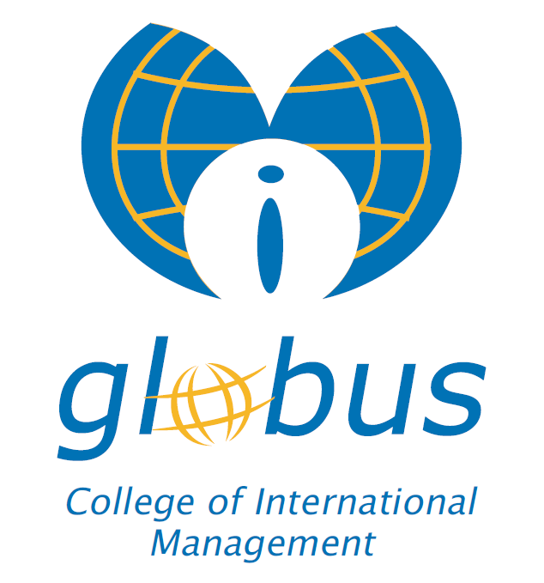

RULES OF PROCEDURE OF THE STANDING COMMITTEE FOR STUDENTS

Prishtina,
2020

Rules of Procedure of the Standing Committee on Students

Article 1
The Student Commission (hereinafter referred to as the Commission) will base its work on the Law on Higher Education of the Republic of Kosovo and on the TSC of the “Globus” College, in accordance with the Bologna process.

Article 2
The work of the Commission is generally not public, so that the Commission is not externally influenced. However, the Commission is obliged to report regularly to the TSC of “Globus” College on its activities.

Article 3
The Commission deals with all aspects of student activities and their participation in the academic processes of "Globus" College and other activities within the "Globus" College.

Article 4
The Rector of “Globus” College is responsible for convening the meetings of the Commission.
However, the Chairman of the Commission must convene the meetings of the Commission in cases when the TSC requests him to do so. Meetings must be convened no later than 40 days after receiving a written request from the Senate.

Article 5
The written request for a meeting of the Committee, together with the points to be discussed, must be sent to the members of the Committee at least seven days before the meeting. Additional documents on the issues to be discussed must be sent no less than five days before the meeting.

Article 6
At the beginning of each meeting, the chairperson of the Committee must request the confirmation of the minutes from the previous meeting and report on the execution (implementation) of the decisions from the previous meeting.

Article 7
The work of the Commission is led by the chairman of the Commission, or in cases when he is not present, is led by a member of the Commission, authorized in advance and clearly authorized by the chairman of the Commission.

Article 8

The Commission consists of five (5) permanent members. One (1) member is appointed by the Rector, two (2) by TSC and two (2) by students. The mandate of the members of the Commission may be renewed.

Article 9
The mandate of the members of the Commission is 3 years, except for the representatives elected by the students who have a one-year mandate, which can be renewed.

Article 10
The Committee may take decisions if more than half of the members of the Committee are present at the meeting. The Chairman of the Commission, or the person authorized by him, at the beginning of the meeting must confirm whether there is a sufficient quorum to make decisions.

Article 11
The Chairman of the Commission should compile a detailed list of participants in the meetings of the Commission.

Article 12
The Chairman of the Commission or the person authorized by him may terminate the meeting if there is no quorum or for any other acceptable reason. In such a case, he must set the exact date and time of the next meeting.

Article 13
The commission takes decisions by a majority vote of the members present. It is the duty of the chairman to inform the Senate of the voting results.

Article 14
The voting procedure is generally open, but the Commission has the right to decide on secret ballot. In such a case the question put to the vote must be clear to Yes or NO.

Article 15
The committee must make the minutes of each meeting and it must clearly state the time, place and date of the meeting, the names of the participating and absent members, as well as the names of other persons invited to participate in the meeting. The minutes must be signed by the chairman of the Commission or the person authorized by him, as well as the record keeper.
Copies of the minutes should be sent to the rector of "Globus" College and TSC of "Globus" College, no later than five days after the meeting.

Article 16
It is the duty of the rector's office to archive the minutes properly.

Article 17
All changes of these procedures can be taken from the procedures defined by TSC.

Article 18
This procedure will be implemented from the day of approval by TSC of "Globus" College.

Prishtina, Chairman of TSC
Dt. 15.09.2020 Rector,
Prof.dr.Nazmi Mustafa

